RANGE OF RADIATION IN AIR

Aim: To determine how far alpha and beta particles penetrate through air.

Hypothesis:

Method:

1. Set up the following apparatus, without the source in place.

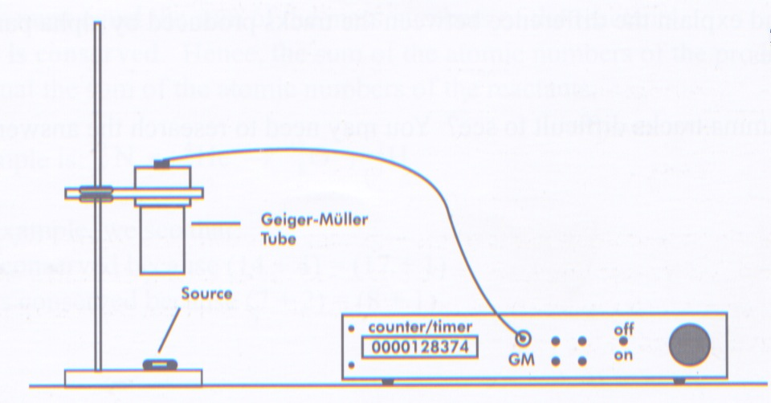

2. Place the Americium-241 source (alpha source) under the Geiger counter and measure the count rate for 60 seconds at the following distances:
1.0 cm, 2.0 cm, 3.0 cm, 4.0 cm and 5.0 cm. Record your observations in a table.

3. Repeat step 2 for the Strontium-90 source (beta source). Record your observations
in a table.

4. Graph the results for both sources - use one graph if possible.

Results:

Alpha Source
Distance (cm) | Count Rate (per minute)
1.0
2.0
3.0
4.0
5.0
Beta Source
Distance (cm) | Count Rate (per minute)
1.0
2.0
3.0
4.0
5.0



Discussion:

Conclusion:

